Thames and Docklands History Group

Derek Morris Commemorative Lecture – 1st April 2026

Intrigue and Espionage in Rotherhithe:
Spain’s illicit recruitment of British shipwrights in 1749

Dr. Catherine Scheybeler

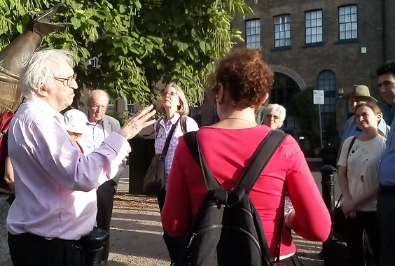

Derek Morris leading one of his tours for the Docklands History Group
Programme
4.30-5.00pm Light Refreshments
5.00pm Dr Chris Ellmers – Welcome and Introduction
5.15pm Professor Sarah Palmer – Derek Morris: An Appreciation
5.30pm Dr Catherine Scheybeler – Derek Morris Commemorative Lecture
6.15pm Questions and Discussion
6.30pm Presentation and Thanks
6.40pm Departure
A Tribute from Ken Cozens
Dear Chris, Ladies & Gentlemen,
I was so pleased to hear that the late Derek Morris's work is to be celebrated by the TDHG this evening. Sadly, I cannot be with you but would just like to remark on the astonishing body of work that dear Derek left us as his legacy. His enthusiasm and dedication in seeking out archives often brought little known local history research to the fore and deserves due recognition. We all owe a huge debt of gratitude to him and I know that many of you, like me, will miss him and his contribution to London history. Derek's son Richard has already placed a bibliography of Derek's publications on his website: https://singsurf.org/stepney/
I too will continue to promote Derek's work through my own contributions on my Academia website page (https://gre.academia.edu/KennethCozens) and elsewhere whenever I can. I greatly miss him, but cherish his work for its depth and quality of research. I hope you will all join with me in thanking Dear Derek for being such a good friend and mentor to many of us too.

Speaker Details
Dr. Catherine Scheybeler is a Lecturer in the War Studies Department at King’s College, London, and is also employed as a Consultant by Lloyd’s Register Foundation. She is the Reviews Editor of the Society of Nautical Research’s journal, The Mariner’s Mirror, and is Chair of their Maritime Heritage Committee. Catherine was born and brought up in Spain where she developed a keen interest in maritime history. She went on to become a historian specialising in the Spanish 18th century navy and was awarded a PhD in War Studies from King’s College, London. Her thesis was on the naval policy of Fernando VI (1746–1759) and the naval regeneration project of the Marquess of La Ensenada, who sent Jorge Juan to London, including Rotherhithe, a stone’s throw from where she lives.
Talk Synopsis
From the beginning of 1749 to April 1750, the southern Thames waterfront, between Bermondsey Wall and Deptford Naval Dockyard, was the scene of a daring espionage and recruitment mission by the Spanish Navy. A Spanish naval officer, Jorge Juan y Santacilia, arrived in London to examine British naval shipbuilding and recruit shipwrights. Although welcomed into London’s naval and scientific elite, he also infiltrated the local shipbuilding community at Rotherhithe, and recruited several shipwrights and shipbuilding artificers to work for the Spanish Royal Naval Dockyards. This led to the a la inglesa or ‘English-style’ of naval construction that would be in place in Spain until 1770. In all, over eighty individuals and their families, mainly from St. Mary’s Rotherhithe, found their way to Spain as a result of Jorge Juan’s efforts. This lecture will focus on these individuals, their community at St. Mary’s Rotherhithe, how they were recruited, their motivations and what their experiences were in Spain.

